Name:Jeevan S U

**Name: Jeevan S U**

**Roll No: 241059038**

**Subject: Cryptology Lab**

**Program: M.E in Cyber Security, MSIS, MAHE**

1. Write a Python script to list all the prime numbers from 1 to 100 using Sieve of Eratosthenes.

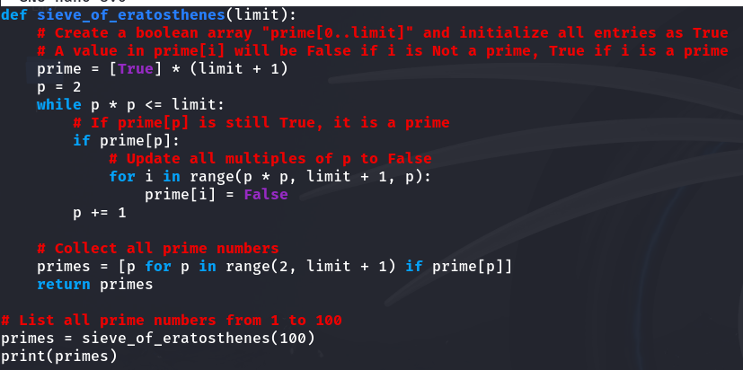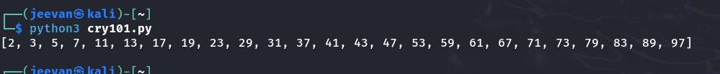

2. Write a Python script to implement RSA algorithm using build in functions (both encryption and decryption)

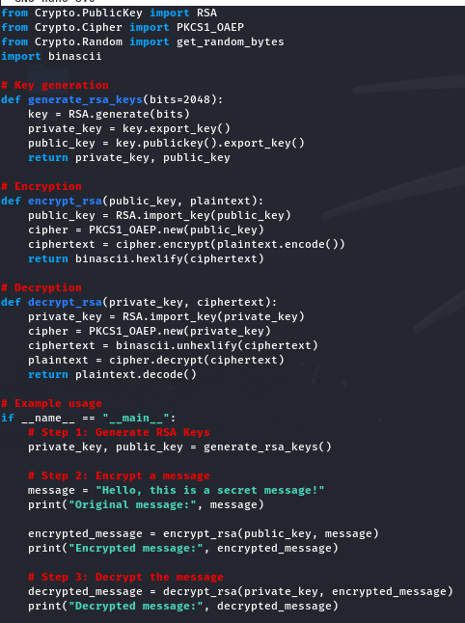

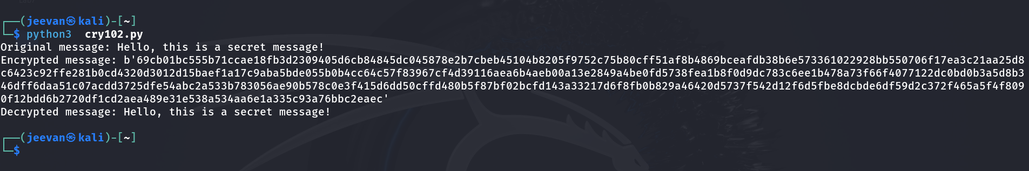

3. Write a Python script to implement RSA algorithm with out using build in functions (both encryption and decryption)

